- In a graph database, each node is a record and each arc is a relationship between two nodes. Graph databases are optimized to represent complex relationships with many foreign keys or many-to-many relationships.
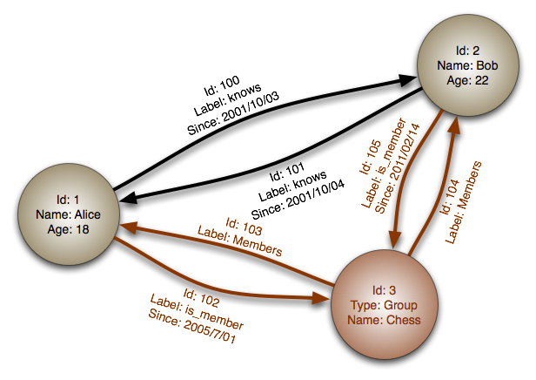

- Graphs databases offer high performance for data models with complex relationships, such as a social network. They are relatively new and are not yet widely-used; it might be more difficult to find development tools and resources. Many graphs can only be accessed with REST APIs.
- For quite a few years now, the received wisdom has been that social data is not relational, and that if you store it in a relational database, you’re doing it wrong.
(http://www.sarahmei.com/blog/2013/11/11/why-you-should-never-use-mongodb/)

